OPTIMALMINE
Project name: OPTIMALMINE. A paradigm shift in mining & quarry efficiency in Europe
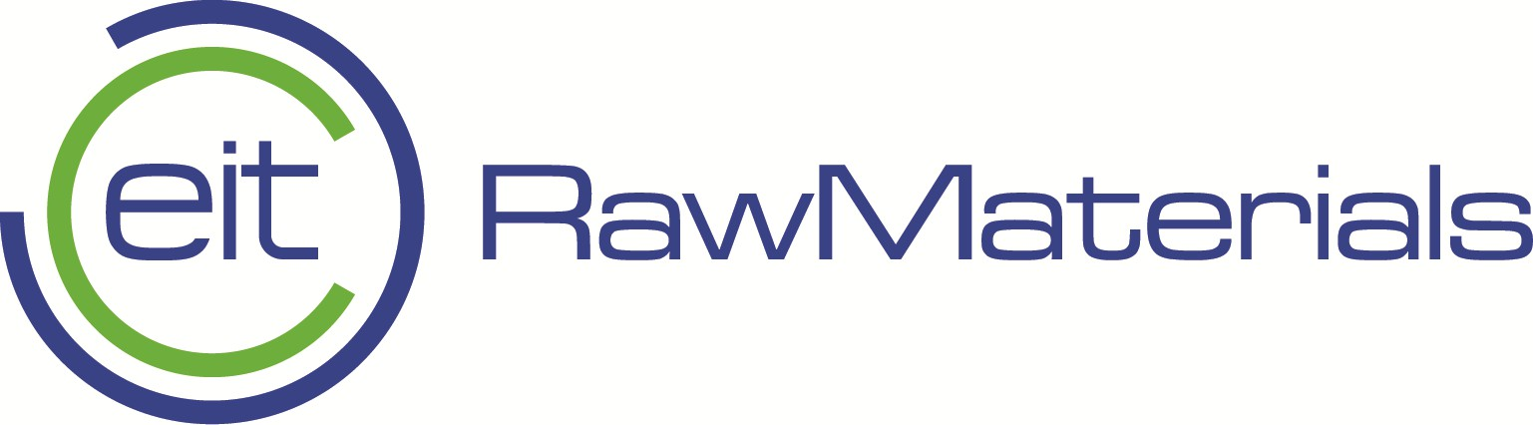 | 

Project duration: 1.6.2025. – 31.5.2027.
Project lead: Università degli Studi di Milano - Bicocca (University of Milano- Bicocca)
Project partners:
Asarel Medet:
Optimalslope Ltd
Università degli Studi di Milano - Bicocca (University of Milano- Bicocca)
University of Zagreb – Faculty of Mining, Geology and Petroleum Engineering (UNIZG-RGNF)
Contact at UNIZG-RGNF : Assoc. Prof. Anamarija Grbeš Babić, PhD

Opis projekta

The OPTIMALMINE project represents a technological breakthrough in the design, management, and efficiency of open-pit mines and quarries across Europe. At the core of the project is Slope Optimiser, a novel geotechnical software application developed by the project partner OptimalSlope Ltd. Unlike the traditional approach of using uniform bench slopes, this software determines the topologically optimal pitwall shape, optimizing ore recovery without compromising safety. Through automated, data-driven optimization, the project aims to achieve cost savings in the order of tens of millions of Euros and contribute to the EU’s strategic priority of increasing domestic production of critical and strategic raw materials required for the net-zero transition. The innovations will be validated at major sites, including the Asarel copper mine in Bulgaria and several quarries across Eastern and South-Eastern Europe (ESEE).
Ciljevi i dosezi projekta

The primary objective of the OPTIMALMINE project is to pilot the adoption of optimal slopes in large open-pit mines and quarries located in Regional Innovation Scheme (RIS) countries. The scope of the project includes:
- Environmental Sustainability: Reducing the carbon footprint by up to 25% and decreasing waste rock and tailings by up to 30%.
- Operational Validation: Refining the Slope Optimiser software to meet the specific needs of RIS mines and providing operational validation through real-world applications.
- Safety and Digitalization: Ensuring consistent pitwall design to improve slope safety and achieving full digitalization of the mine design workflow.
- Capacity Building: Training professionals and students to use innovative tools to ensure the long-term adoption of these technologies within the European raw materials sector.
- Strategic Alignment: Contributing to the “Responsible Sourcing” lighthouse by strengthening raw material supply and reducing the environmental footprint of extraction.

The role of UNIZG - RGNF

- LCA Study (Work Package 4): The Faculty leads the Life Cycle Assessment (LCA) to systematically evaluate the environmental benefits of the project’s innovations.
- Quarry Applications (Work Package 2): The Faculty coordinates the application of topological slope optimization in quarries in Croatia, Italy, and Bulgaria. Activities include reviewing geotechnical data, designing quarry expansion phases, and validating slope safety.
- Education and Training: The Faculty contributes to Work Package 5 through educational programs and raw materials–related short courses for PhD and Master’s students.
- Technical Support: The Faculty provides support to Work Package 1 related to geotechnical modeling and the design of large open-pit mines.

